Comparative Analysis Of Brain Tumor Classification
Using Convolutional Neural Network



Under The Supervision Of

Dr. Humera Bashir

Submitted By

Syeda Maheen Zaidi | Seat # B18101115
Nimra Shahab | Seat # B18101090

Department of Computer Science
University of Karachi

A report submitted to the

Department of Computer Science
in partial fulfillment of the requirements for the
degree
Bachelor of Science
in
Computer Science
by
Syeda Maheen Zaidi
Nimra Shahab
University Of Karachi
CERTIFICATE

This is to certify that the project “Brain Tumor Classification Using CNN” is completed under the supervision of Dr. Humera Bashir. A report of the project is also submitted to the department of computer science in fulfillment of the requirement for the degree BSCS by Syeda Maheen Zaidi(B18101115) and Nimra Shahab(B18101090).

Remarks:

Signature
Supervisor
Dr. Humera Bashir

ACKNOWLEDGMENT:

We would like to express our sincere gratitude and appreciation to all those who helped us in the journey of completing this project. Many thanks to our project supervisor Dr. Humera Bashir for her continuous guidance and support throughout the duration of this project. Her expertise and encouragement played a vital role in shaping the direction of our research and enhancing the overall quality of our project.
We are also grateful to the faculty of UBIT for providing the conductive and learning environment for our research. Last but not the least thanks to all our friends and family for their silent support, It would not be possible without them.

Syeda Maheen Zaidi (B18101115)
Nimra Shahab(B18101090)
DATE
29 Jan,2024

Table Of Contents:
Title……………………………………………………………………………………………………….1
  - Statement of submission………………………………………………………………….2
  - Certificate……………………………………………….…………………………………….3
  - Acknowledgment.....................................................................................4
  - List of figures.........................................................................................7
  - List of tables……………………………………………………………………….……..….8
  - Abstract…………………………………………………………………………………..……9
CHAPTER:1 INTRODUCTION………………………………………………………………………………..11
1.1 BACKGROUND…………………………………………………………………………………………..11
1.2 MOTIVATION…………………………………………………………………………………………….12
1.3 OBJECTIVES……………………………………………………………………………………………….12
  - CHAPTER:2 LITERATURE REVIEW………………………………………………………………………..14
2.1 EXISTING APPROACHES……………………………………………………………………………14
2.2 GAP IN THE LITERATURE…………………………………………………………………………15
CHAPTER:3 METHODOLOGY………………………………………………………………………………..16
3.1 DATASET………………………………………………………………………………………………….15
3.1.1 DATASET STRUCTURE…………………………………………………………………….16
3.2 DATA PREPROCESSING…………………………………………………………………………...16
3.2.1 IMAGE PREPROCESSING/AUGMENTATION…………………………………...16
3.3 MODEL ARCHITECTURES………………………………………………………………………….17
3.3.1 23-LAYERS CNN MODEL………………………………………………………………..17
3.3.2 FINE-TUNED VGG16 MODEL………………………………………………………...20
3.4 MODEL COMPILATION AND TRAINING…………………………………………………..21
3.4.1 COMPILING 23-LAYERS CNN………………………………………………………..21
3.4.2 COMPILING FINE-TUNED VGG16 MODEL…………………………………….22
  - CHAPTER:4 RESULTS……………………………………………………………………………………………22
4.1 EVALUATION METRICS…………………………………………………………………………..22
  - 4.1.1 23-LAYERS CNN……………………………………………………………………………22
4.2 CONFUSION MATRICES………………………………………………………………………….24
  - 4.2.1 23-Layers CNN Model Confusion Matrix…………………………………….24
  - 4.2.2 Fine-tuned VGG16 Model Confusion Matrix………………………………25
4.3 CLASSIFICATION REPORTS…………………………………………………………………….27
  - 4.3.1 23-layers CNN model classification report ………………………………..27
  - 4.3.2 Fin-tuned VGG16 model classification report…………………………...27
4.4 CONCLUSION AND OVERALL RESULT…………………………………………………..28
CHAPTER:5 DISCUSSION……………………………………………………………………………….….29
5.1 COMPARATIVE ANALYSIS…………………………………………………………………....29
  - 5.1.1 MODELS’ VALIDATION RESULTS BAR CHARTS
5.2 LIMITATIONS………………………………………………………………………………..30
CHAPTER:6 CONCLUSION:…………………………………………………………………………31
6.1 KEY FINDINGS ……………………………………………………………………………………………31
6.2 Future Work……………………………………………………………………………………………..31
APPENDIX………………………………………………………………………………………………………….34
REFERENCES……………………………………………………………………………………………………….42

  - LIST OF FIGURES :
FIGURE 3.1 SAMPLE DATASET…………………………………………………..…………………………18
FIGURE 3.3 PROPOSED ARCHITECTURE OF THE MODEL…………………………………….……..21
FIGURE 3.3.1CODE SNIPPET 23 LAYERS CNN MODEL…………………………………..…………..24
FIGURE 3.3.2: CODE SNIPPET FINE-TUNED VGG16 MODEL…………………………………….....25
FIGURE 4.1.1: VISUAL REPRESENTATION OF 23 LAYERS CNN MODEL ACCURACY ……..….28
FIGURE 4.1.2 VISUAL REPRESENTATION OF FINE-TUNED VGG16 MODEL ACCURACY….…29
FIGURE 4.2.1(a): 23 LAYERS CNN TEST SET CONFUSION MATRIX...................................…...31
FIGURE 4.2.1(b): 23 LAYERS CNN VALIDATION SET CONFUSION MATRIX………………...…32
FIGURE 4.2.2(a): FINE-TUNED VGG16 TEST SET CONFUSION MATRIX…………………….…..33
FIGURE 4.2.3(b): FINE-TUNED VGG16 VALIDATION SET CONFUSION MATRIX………..…...33
FIGURE 5.1.1 : CNN MODEL BAR CHART………………………………………………………………38
FIGURE 5.1.2: FINE-TUNED VGG16 MODEL BAR CHART…………………………………………38

LIST OF TABLES:
TABLE 3.1.1 NUMBER OF MRI SLICES…………………………………………………………….…19
TABLE 3.2.1 IMAGE AUGMENTATION……….……………………………………………………..20
TABLE 4.1.1 23 LAYERS CNN MODEL ACCURACY AND LOSS…………………………….…27
TABLE 4.1.2 FINE-TUNED VGG16 MODEL ACCURACY AND LOSS…………….…….……..29
TABLE 4.3.1(a) 23 LAYERS CNN TEST SET CLASSIFICATION REPORT…………………….34
TABLE 4.3.1(b) 23 LAYERS CNN VALIDATION SET CLASSIFICATION REPORT…..…….34
TABLE 4.3.2(a) FINE-TUNED VGG16 TEST SET CLASSIFICATION REPORT………….…..35
TABLE 4.3.2(b) FINE-TUNED VGG16 VALIDATION SET CLASSIFICATION REPORT.….35

ABSTRACT

The early and accurate classification of brain tumors is crucial for effective medical intervention. Our project delves into the realm of medical diagnostics, specifically targeting brain tumor classification through the power of artificial intelligence. Leveraging the capabilities of deep learning models, we devised and implemented two sophisticated architectures – a 23-Layers Convolutional Neural Network (CNN) and a Fine-tuned VGG16 Model. These models are trained and evaluated using a meticulously curated dataset, comprising various brain tumor classes. The dataset (publicly available) comprises brain MRI images with four classes: no tumor, pituitary, meningioma, and glioma. A comprehensive literature review reveals the need for segmentation-free models that overcome the challenges associated with handcrafted feature extraction. This study introduces two models: a 23-Layers CNN and a Fine-tuned VGG16, both designed to handle binary (normal and abnormal) and multiclass (meningioma, glioma, pituitary) classifications.
Methodologically, the dataset undergoes preprocessing, and the models are trained with different configurations. The 23-Layers CNN utilizes convolutional layers, pooling, and dense layers, while the Fine-tuned VGG16 incorporates a pre-trained VGG16 base model. Training and evaluation involve standard deep learning practices, with metrics
Confusion matrices highlight the correct and incorrect predictions, showing the distribution of classifications for each class. The 23-Layers CNN displayed proficiency in distinguishing tumor types, with precision, recall, and F1-score metrics indicating a balanced performance. The Fine-tuned VGG16, while achieving a commendable accuracy, showed some limitations in specific class predictions. The 23-Layers CNN exhibited promising results with a minimal loss of 0.0951 and an accuracy of 96.34%. On the other hand, the Fine-tuned VGG16 model achieved a loss of 0.3027 and an accuracy of 87.41%. Detailed evaluation metrics. Comparison with existing literature showcases the competitiveness of the proposed models. The 23-Layers CNN outperformed the Fine-tuned VGG16 in terms of accuracy, emphasizing its effectiveness in brain tumor classification. These segmentation-free models contribute to the field by offering reliable tools for accurate and timely diagnosis. The discussion section explores the strengths and limitations of both models, providing avenues for future improvements. The findings underscore the significance of leveraging deep learning for medical image analysis, particularly in the domain of brain tumor classification.

CHAPTER 1: INTRODUCTION

BACKGROUND
Medical imaging has witnessed remarkable advancements, becoming an indispensable tool for diagnosing and treating various health conditions. Among these imaging modalities, Magnetic Resonance Imaging (MRI) stands out for its ability to provide detailed and non-invasive views of the human body. Within the realm of medical imaging, the detection and characterization of brain tumors present both clinical challenges and opportunities for technological innovation.

Deep learning models, particularly Convolutional Neural Networks (CNNs), have demonstrated exceptional capabilities in recognizing patterns and features within images. These models can learn intricate representations from vast datasets, leading to automated and precise image classification. The application of deep learning in medical imaging has paved the way for the development of innovative approaches to brain tumorclassification.
Transfer learning, a technique where a model trained on one task is adapted for a related task, has gained prominence in medical imaging. Fine-tuning pre-trained models, such as VGG16, with new medical imaging datasets allows for the extraction of features relevant to specific tasks, even with limited labeled data. This approach has shown promise in achieving high accuracy in medical image classification tasks.
The integration of deep learning models into medical diagnostics aligns with the broader trend toward precision medicine and personalized healthcare. Automated brain tumor classification not only improves diagnostic speed but also has the potential to contribute to more tailored treatment plans, thereby enhancing patient outcomes.

MOTIVATION:
The motivation behind this research is grounded in the need to address critical challenges in the diagnosis of brain tumors. Traditional methods, while effective, often require significant time and human effort. Moreover, the subjectivity inherent in manual interpretation can lead to variations in diagnoses.
By harnessing the power of Convolutional Neural Networks (CNNs) and transfer learning, we aim to develop automated systems that can assist healthcare professionals in accurately and efficiently classifying brain tumors.
One of the primary motivations is to contribute to the creation of tools that facilitate timely and accurate diagnoses. Rapid identification and classification of brain tumors are crucial for initiating prompt treatment plans, ultimately improving patient outcomes. Automation through deep learning models has the potential to significantly reduce the time required for diagnosis.
In summary, our motivation is deeply rooted in addressing existing challenges in brain tumor diagnosis, leveraging cutting-edge technologies, and contributing to the broader goal of advancing healthcare through the fusion of artificial intelligence and medical expertise.

OBJECTIVES:
The primary objective of this research is to design and implement a robust 23-Layers Convolutional Neural Network (CNN) model for the classification of brain tumors. This involves the creation of a deep neural network architecture capable of effectively learning intricate patterns and features extracted from medical images, specifically MRI scans.
A key objective is to explore the applicability of a fine-tuned VGG16 model for brain tumor classification. Transfer learning from pre-trained models, such as VGG16, allows us to leverage knowledge gained from large-scale image datasets, enhancing the performance of our model on medical images despite limited labeled data.
To overcome data limitations and enhance model generalization, we aim to employ data augmentation techniques during the training process. Augmentation methods such as rotation, zooming, and flipping will be applied to the available medical images, diversifying the dataset and improving the model's ability to handle variations in input data.
The research involves acquiring and preparing a specialized medical dataset containing MRI scans of brain tumors. The dataset will be divided into training and testing sets, ensuring proper validation and evaluation of the developed models. The use of a domain-specific dataset is crucial for model generalization to medical imaging tasks.
To assess the effectiveness of the models, we will employ confusion matrices and relevant evaluation metrics such as precision, recall, and F1-score. The performance metrics will provide insights into the models' ability to accurately classify brain tumors into multiple categories and assist in comparing the 23-Layers CNN model with the fine-tuned VGG16 model. The objectives encompass model development, exploration of transfer learning, addressing data limitations, thorough evaluation, and a commitment to contributing meaningful advancements to the domain of automated braintumor diagnosis.

CHAPTER:2 LITERATURE REVIEW

EXISTING APPROACHES:

Early attempts at brain tumor diagnosis involved traditional image processing techniques. These methods often incorporated handcrafted features, segmentation algorithms, and region-based approaches. For example, Shanaka et al. [52] employed a combination of deep learning and active contouring to segment tumor regions. However, these techniques had limitations in handling complex and diverse image patterns.
The emergence of Convolutional Neural Networks (CNNs) revolutionized medical image analysis. Studies by Francisco et al. [54] and Emrah et al. [55] demonstrated the efficacy of CNNs in achieving high classification accuracy for brain tumors. CNNs excel at automatically learning hierarchical features from images, eliminating the need for manual feature engineering.Transfer learning, particularly using pre-trained models, has gained prominence in medical image analysis. Researchers like Swati et al. [37] and Sajjad et al. [39] applied pre-trained VGG19 models to brain tumor datasets, showcasing the transferability of knowledge from large image datasets to medical domains. However, the effectiveness of transfer learning depends on the choice of architecture and dataset compatibility.

GAP IN THE LITERATURE:

Several studies applying deep learning models to brain tumor diagnosis lack comprehensive exploration of dropout and regularization strategies. Dropout, a technique to prevent overfitting, and regularization methods can significantly enhance model generalization. However, their application in the context of brain tumor classification remains an underexplored area.
The interpretability of deep learning models in the context of brain tumor diagnosis remains a critical gap. Understanding how models arrive at specific predictions is essential for gaining trust from healthcare professionals and facilitating clinical adoption. Exploring interpretable deep learning architectures and visualization techniques is an area that requires more attention.
Many existing approaches do not adequately emphasize the use of data augmentation techniques. Augmenting the dataset through transformations such as rotation, zooming, and flipping can enhance model robustness and improve performance, especially when working with limited labeled medical images.
While existing approaches have made significant contributions to automated brain tumor diagnosis, there are evident gaps in the literature. Addressing these gaps, such as optimizing regularization strategies, exploring diverse transfer learning architectures, emphasizing data augmentation, and enhancing model interpretability, can pave the way for more effective and trustworthy diagnostic models.

CHAPTER:3 METHODOLOGY

Two different models were implemented for image classification: a 23-Layers CNN model and a Fine-tuned VGG16 model. The dataset used for training and testing is organized into classes, and data augmentation techniques are applied to the training set.. Both models are trained using the “fit” method on the training set with data augmentation. The training progress is visualized with accuracy plots for each epoch. Accuracy plots are generated for both models, showing the training and validation accuracy over epochs. Threshold adjustment is applied to the predicted probabilities to convert them into class labels. The adjusted predictions are used to calculate new confusion matrices and classification reports. The final results include accuracy, loss, confusion matrices, and classification reports for both models.

Dataset:
The dataset was obtained from (https://www.kaggle.com/datasets/masoudnickparvar/brain-tumor-mri-dataset/data) . It comprises images of brain tumors, divided into the following categories:
1 - Glioma
2 - Meningioma
3 - Pituitary
4 - No Tumor.
This dataset is a combination of the following three datasets:
figshare
SARTAJ dataset
Br35H
This dataset contains 7023 images of human brain MRI images which are classified into 4 classes: glioma - meningioma - no tumor and pituitary.
Where, each folder contains different numbers of MRI images in the testing dataset. The training dataset each contains larger number of slices in each folder to better train the models. No tumor class images were taken from the Br35H dataset.
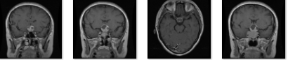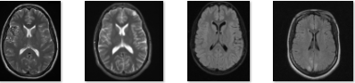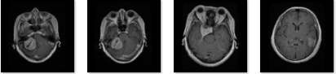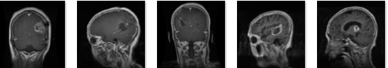
MENINGIOMA
NO TUMOR
GLIOMA
PITUITARY
FIGURE 3.1 SAMPLE DATASET

    - Dataset Structure:
The dataset is organized into three main folders: "TRAINING" and "TESTING” and “VALIDATION”. Each of these folders contains subfolders for each tumor class, which are (GLIOMA, MENINGIOMA, PITUITARY AND NO-TUMOR).
TUMOR CLASS | TRAINING MRI SLICES | TESTING MRI  SLICES | VALIDATION MRI  SLICES
GLIOMA | 1321 | 200 | 100
MENINGIOMA | 1339 | 202 | 103
NO TUMOR | 1595 | 335 | 70
PITUITARY | 1457 | 200 | 100
MRI SLICES IN DATASET:

Table3.1.1 NUMBER OF MRI SLICES

  - DATA PREPROCESSING:
    - Image Preprocessing/AUGMENTATION:
The images were preprocessed using the TensorFlow ImageDataGenerator. Key preprocessing steps include rescaling, shearing, zooming, and horizontal flipping to enhance model generalization.
SERIAL NUMBER | PARAMETER | VALUE
1 | RESCALE | 1./255
2 | SHEAR RANGE | 0.2
3 | ZOOM RANGE | 0.2
4 | ROTATION RANGE | 90
5 | WIDTH SHIFT RANGE | 0.1
6 | HEIGHT SHIFT RANGE | 0.1
7 | HORIZONTAL FLIP | TRUE
8 | VERTICAL FLIP | TRUE

Table 3.2.1 Image Augmentation

  - Model Architecture:
Two different models were implemented: a 23-Layers CNN model and a Fine-tuned VGG16 model on the same dataset. Both models were designed to handle 224x224 pixel images with three color channels.

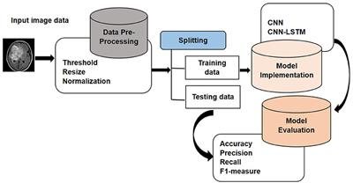
Resize, Rescale
CNN AND VGG16

V
FIGURE 3.3: Proposed architecture of the model

    - 23-LAYERS CNN MODEL:
A "23 layers CNN" typically refers to a Convolutional Neural Network (CNN) architecture with 23 layers, including convolutional layers, pooling layers, and fully connected layers. The specific architecture and layer types can vary, but such networks are often used for image classification tasks. It was implemented using tensorflow library in python. The architecture consists of convolutional layers with increasing filters, max-pooling layers for downsampling, dropout layers for regularization, and fully connected layers. The model is compiled using the Adam optimizer and categorical crossentropy loss .The following equation describes the convolutional layer
$$C\left(h,d\right)=\left(k*f\right)\left(h,d\right)= \sum_{i}{}\sum_{j}{} k\left(h-i,d-j\right)f(i,j)$$
In the convolutional layer, K is the image of size (h,d) and (i,j) corresponds to the kernel size value with an f number of filters. As an activation function we use Rectified linear unit (ReLU). The ReLU activation function introduces non-linearity, and dropout layers help prevent overfitting.. It represents as
$$f\left(z\right)=max(0,z)$$

ARCHITECTURE:
INPUT LAYER:
Shape: “(img_height,img_width,3)” img_height and img_width are the height and width of the input images, and 3 corresponds to the number of color channels (RGB)..
CONVOLUTIONAL LAYER 1:
Filters: 32
Kernel Size: (3, 3)
Activation: ReLU (Rectified Linear Unit)
MAX POOLING LAYER 1:
Pool size: (2,2)
CONVOLUTIONAL LAYER 2:
Filters: 64
Kernel Size: (3, 3)
Activation: ReLU
Dropout: 0.2
MAX POOLING LAYER 2:
Pool size: (2,2)
CONVOLUTIONAL LAYER 3:
Filters: 128
Kernel Size: (3, 3)
Activation: ReLU
Dropout: 0.2
MAX POOLING LAYER 3:
Pool size: (2,2).
CONVOLUTIONAL LAYER 4:
Filters: 256
Kernel Size: (3, 3)
Activation: ReLU
Dropout: 0.2
MAX POOLING LAYER 4:
Pool size: (2,2).
CONVOLUTIONAL LAYER 5:
Filters: 512
Kernel Size: (3, 3)
Activation: ReLU
Dropout: 0.2
MAX POOLING LAYER 5:
Pool size: (2,2).
FLATTEN LAYER:
Flattens the 3D output to 1D for the fully connected layers.
DENSE LAYER 1:
Units: 4096.
Activation: RELU.
DENSE LAYER 2: (output layer):
Units: 4 (for multi-class classification)
Activation: Softmax (for probability distribution over classes).
$$softmax\left(z\right)j=\frac{exp⁡(zj)}{\sum_{i=1}^{n}{exp⁡(xi)}}$$
The Softmax activation in the output layer provides a probability distribution across the defined classes, facilitating multi-class classification. The model aims to learn hierarchical representations of brain tumor images through these layers, ultimately achieving accurate classification. Adjustments to hyperparameters and layer configurations can be made based on the specific characteristics of the dataset and the desired model performance.
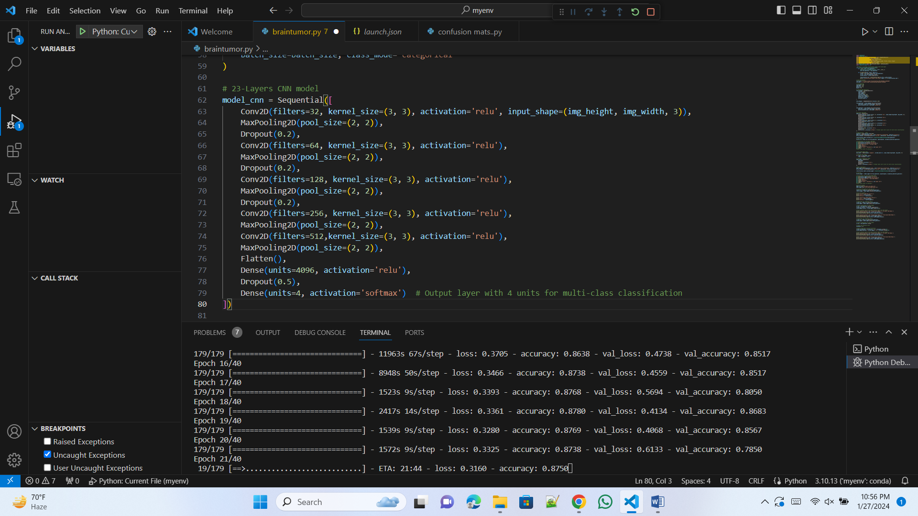
FIGURE 3.3.1: Code snippet – 23-Layers CNN model

    - Fine-tuned VGG16 Model:
A fine-tuned model, in the context of deep learning, typically refers to a pre-trained model that is further trained on a specific task or dataset. Fine-tuning is often applied to transfer learning, where a model trained on a large dataset for a general task is adapted to a smaller dataset or a more specific task.
LOADING PRE-TRAINED MODEL: The VGG16 model is loaded with pre-trained weights from the ImageNet dataset. This means that the model has already learned useful features from a large dataset containing a wide variety of images.
FREEZING THE LAYERS: The layers of the pre-trained VGG16 model are frozen, meaning their weights will not be updated during the fine-tuning process. This helps to retain the valuable features learned during pre-training.
ADDING ADDITIONAL LAYERS: A new Sequential model (model_vgg16) is created by adding the pre-trained VGG16 base model followed by additional layers. These additional layers are specific to your task. In this case, there is a Flatten layer to convert the 4D tensor output from the base model to a 1D tensor, a dense layer with 256 units and ReLU activation, a dropout layer for regularization, and the output layer with 4 units for multi-class classification using softmax activation.
COMPILING AND TRAINING: The fine-tuned model is compiled with an optimizer ('adam' in this case), a loss function ('categorical_crossentropy' for multi-class classification), and metrics ('accuracy' in this case).The fine-tuned model is trained using the fit method on the training generator, and the training history is stored in the history_vgg16 variable.
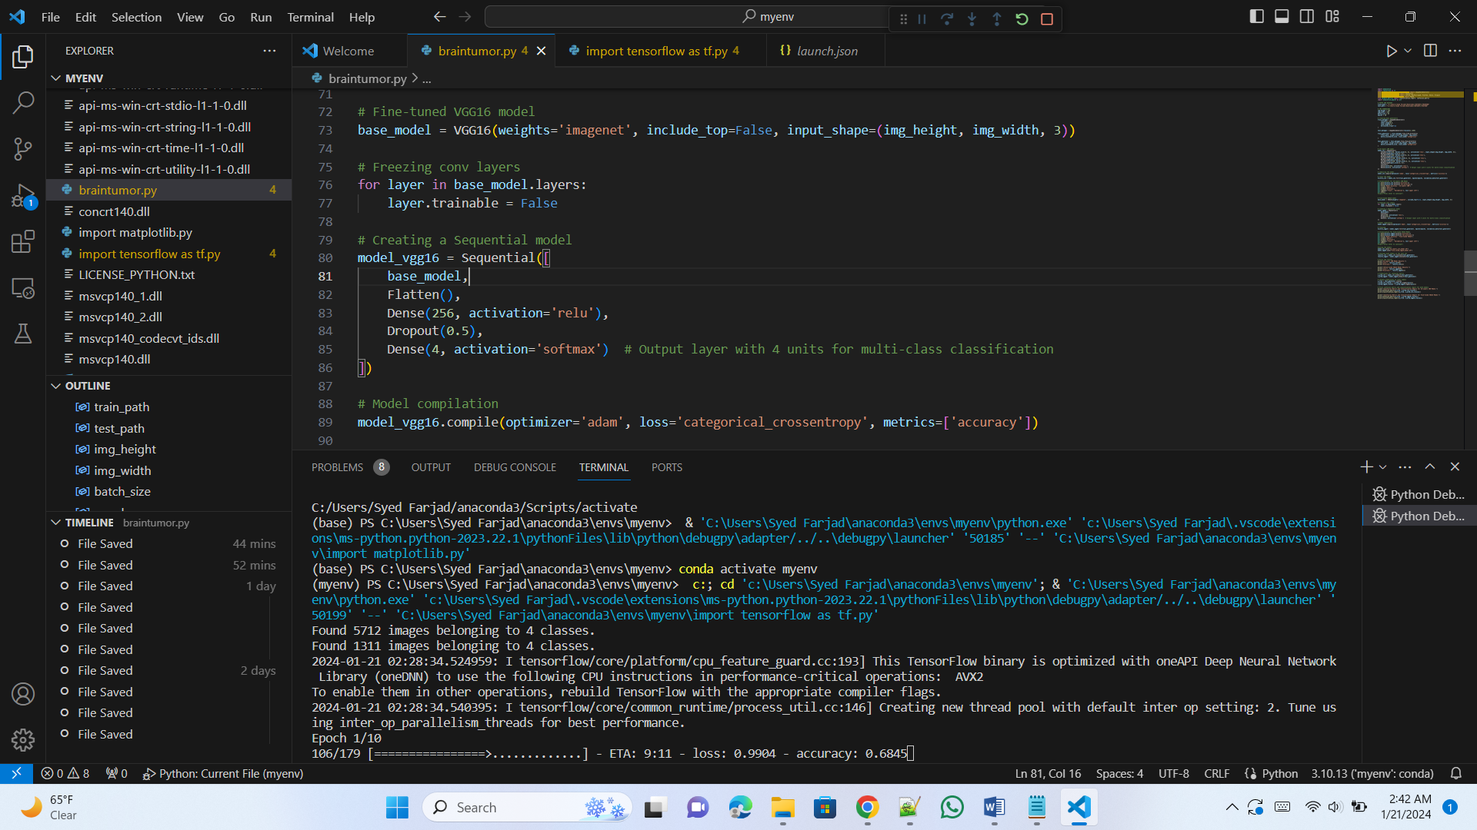
FIGURE 3.3.2: Code snippet- FINE TUNED VGG16 MODEL:
  - MODEL COMPILATION AND TRAINING:
    - Compile the 23-Layers CNN model:
Optimizer: Adam
Learning rate= 0.001
Loss Function: Categorical Crossentropy (for multi-class classification)
Metrics: Accuracy
Train the model on “training” dataset:
Epochs: 30
Batch Size: 32
Validation Data: Validation set
3.4.2 COMPILING FINE-TUNED VGG16:
Compile the Fine-tuned VGG16 model:
Optimizer: Adam
Loss Function: Categorical Crossentropy (for multi-class classification)
Metrics: Accuracy
Train the model on “training” dataset:
Epochs: 30
Batch Size: 32
Validation Data: Validation
This methodology provides a detailed overview of the dataset, data preprocessing steps, and the architecture, compilation, and training of both the 23-Layers CNN and the Fine-tuned VGG16 model.

CHAPTER 4: RESULTS

  - EVALUATION METRICS:
The performance of the developed models was assessed using key evaluation metrics, providing a comprehensive understanding of their capabilities.
 | TESTING | VALIDATION
ACCURACY | 0.9392 | 0.9249
LOSS | 0.1611 | 0.2209
    - 23-LAYERS CNN:
LOSS:
The loss value represents the model's deviation from correct predictions. A lower loss indicates better convergence during training.
ACCURACY:
Accuracy measures the proportion of correctly classified instances. A higher accuracy percentage signifies a more effective model.

TABLE 4.1.1: 23 LAYERS CNN MODEL ACCURACY AND LOSS

    - VISUAL REPRESENTATION OF 23 LAYERS CNN MODEL ACCURACY
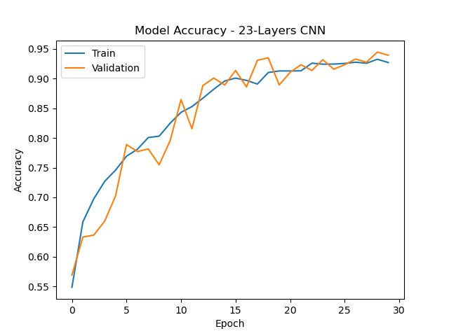
FIGURE 4.1.1 23 LAYERS CNN MODEL ACCURACY
    - FINE-TUNED VGG16 MODEL:
Loss:
Similar to the 23-Layers CNN model, a lower loss value indicates effective training and model convergence.
Accuracy:
The accuracy percentage reflects the proportion of correctly predicted instances by the
Fine-tuned VGG16 model.
 | TESTING | VALIDATION
ACCURACY | 0.8561 | 0.8257
LOSS | 0.3733 | 0.4555

TABLE 4.1.2 FINETUNED VGG16 MODEL ACCURACY AND LOSS

    - VISUAL REPRESENTATION OF FINETUNED VGG16 MODEL ACCURACY 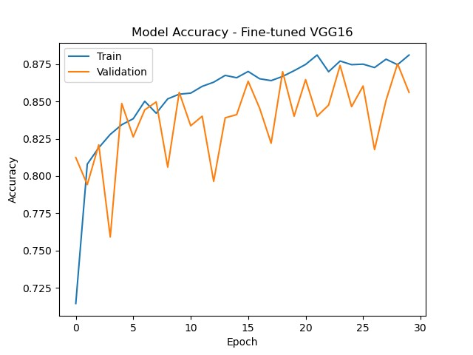
FIGURE 4.1.2 FINETUNED VGG16 MODEL ACCURACY
  - CONFUSION MATRICES:
A confusion matrix is a table used in classification to evaluate the performance of a machine learning model. It provides a detailed breakdown of predictions and actual outcomes, categorizing them into different groups. The matrix is particularly useful in multi-class classification but is also applicable to binary classification.
The key components of a confusion matrix include:
True Positives (TP):
Instances correctly predicted as the positive class.
True Negatives (TN):
Instances correctly predicted as the negative class.
False Positives (FP) - Type I Error:
Instances incorrectly predicted as positive when they are negative.
False Negatives (FN) - Type II Error:
Instances incorrectly predicted as negative when they are positive.
    - 23-Layers CNN Model Confusion Matrix
The confusion matrix for the 23-Layers CNN model shows the distribution of true positive, true negative, false positive, and false negative predictions for each class. This matrix aids in understanding the model's strengths and weaknesses in classifying different brain tumor classes.
    - (a) 23 LAYERS CNN MODEL TEST SET CONFUSION MATRIX
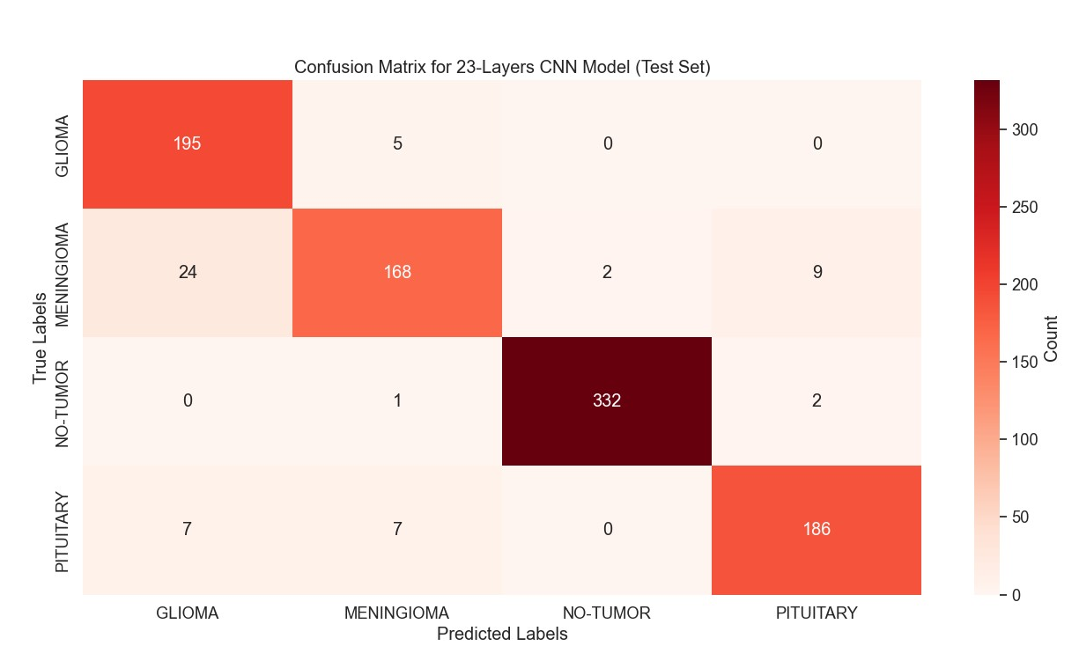
FIGURE 4.2.1(a): 23 LAYERS CNN MODEL TEST SET CONFUSION MATRIX
    - (b) 23 LAYERS CNN MODEL VALIDATION SET CONFUSION MATRIX 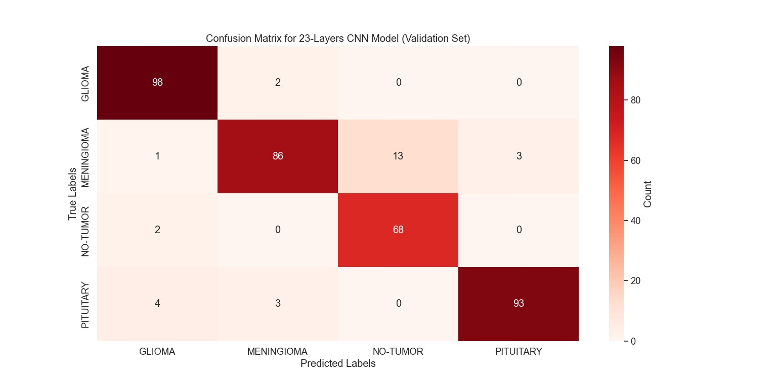
FIGURE 4.2.1(b): 23 LAYERS CNN MODEL VALIDATION SET CONFUSION MATRIX
    - Fine-tuned VGG16 Model Confusion Matrix:
Similar to the 23-Layers CNN model, the confusion matrix for the Fine-tuned VGG16 model provides a detailed breakdown of predicted and actual class labels, allowing a nuanced evaluation of the model' s performance.

    - (a): FINE TUNED VGG16 TEST SET CONFUSION MATRIX
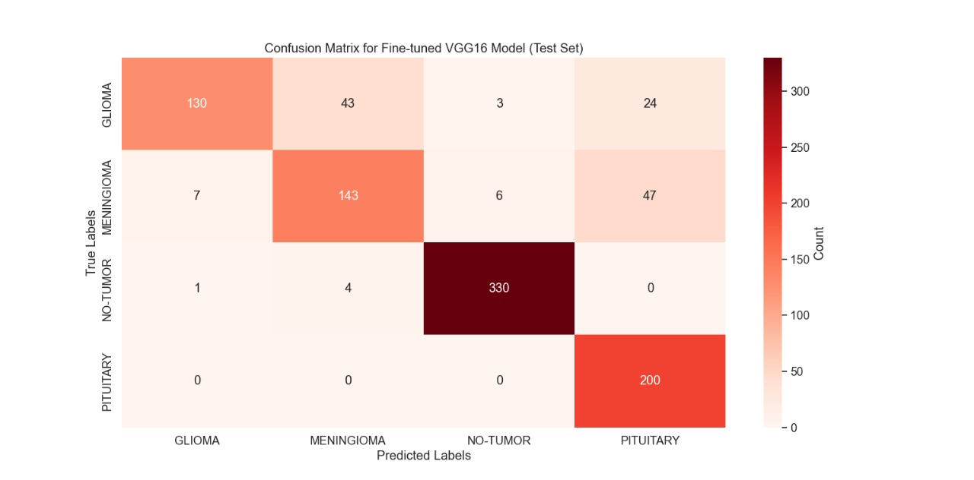
FIGURE 4.2.2(a): FINE-TUNED VGG16 test set confusion matrix

    - (b): FINE-TUNED VGG16 VALIDATION SET CONFUSION MATRIX.
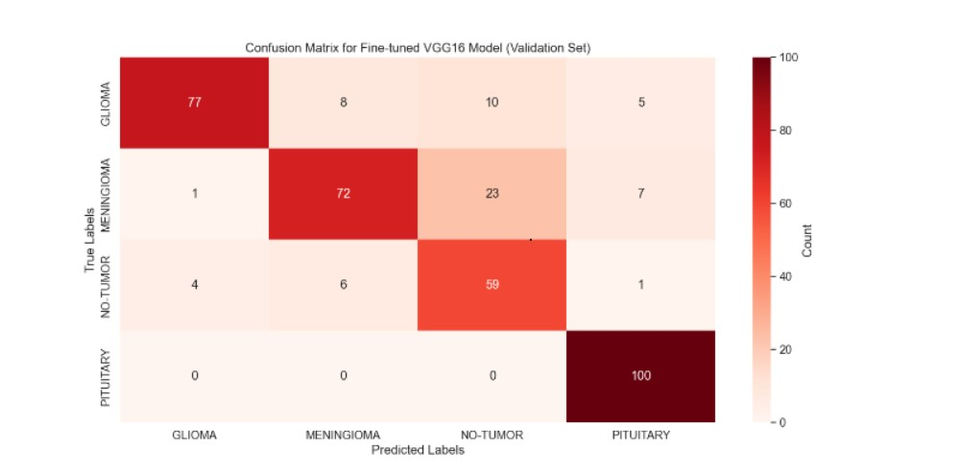
FIGURE 4.2.2(b) FINE-TUNED VGG16 validation set confusion matrix
Class | Precision | Recall | F1-Score | Support
GLIOMA | 0.86 | 0.97 | 0.92 | 200
MENINGIOMA | 0.93 | 0.83 | 0.88 | 203
NO TUMOR | 0.99 | 0.99 | 0.99 | 335
PITUITARY | 0.94 | 0.93 | 0.94 | 200
  - CLASSIFICATION REPORTS:
Detailed classification reports offer per-class metrics such as precision, recall, and F1-score.
4.3.1 23-LAYERS CNN MODEL CLASSIFICATION REPORTS:
(a) 23-LAYERS CNN MODEL TEST SET CLASSIFICATION REPORT:

Table 4.3.1(a): 23 LAYERS CNN TEST SET CLASSIFICATION REPORT

Class | Precision | Recall | F1-Score | Support
GLIOMA | 0.93 | 0.98 | 0.96 | 100
MENINGIOMA | 0.95 | 0.83 | 0.89 | 103
NO TUMOR | 0.84 | 0.97 | 0.90 | 70
PITUITARY | 0.97 | 0.93 | 0.95 | 100
(b) 23-LAYERS CNN MODEL VALIDATION SET CLASSIFICATION REPORT:

Table 4.3.1(b): 23 LAYERS CNN VALIDATION SET CLASSIFICATION REPORT

Class | Precision | Recall | F1-Score | Support
GLIOMA | 0.94 | 0.65 | 0.77 | 200
MENINGIOMA | 0.75 | 0.70 | 0.73 | 203
NO TUMOR | 0.97 | 0.99 | 0.98 | 335
PITUITARY | 0.74 | 1.00 | 0.85 | 200
    - FINE-TUNED VGG16 MODEL CLASSIFICATION REPORTS:
(a) FINE-TUNED VGG16 MODEL TEST SET CLASSIFICATION REPORT:

Table 4.3.2(a): FINE-TUNED VGG16 MODEL TEST SET CLASSIFICATION REPORT

Class | Precision | Recall | F1-Score | Support
GLIOMA | 0.94 | 0.77 | 0.85 | 100
MENINGIOMA | 0.84 | 0.70 | 0.76 | 103
NO TUMOR | 0.64 | 0.84 | 0.73 | 70
PITUITARY | 0.88 | 1.00 | 0.94 | 100
(b) FINE-TUNED VGG16 MODEL VALIDATION SET CLASSIFICATION REPORT:

Table 4.3.2(b): FINE-TUNED VGG16 VALIDATION SET CLASSIFICATION REPORT
Precision: The percentage of correctly predicted instances among the predicted
instances for each class
$$Precision=\frac{TP}{TP+FP}$$Recall: The percentage of correctly predicted instances among the actual instances for each class
$$Recall=\frac{TP}{TP+FN}$$F1 Score: The harmonic mean of precision and recall
$$F1-Score=2*\frac{recall*precision}{recall+precision}$$Support: The number of actual instances for each class.
$$\frac{TP+TN}{TP+TN+FP+FN}$$
  - CONCLUSION AND OVERALL RESULTS:
The extensive exploration of brain tumor classification using the developed 23-Layers CNN and Fine-tuned VGG16 models has provided valuable insights into the efficacy of these architectures. The evaluation metrics offer a comprehensive understanding of the models' performance across different classes.
The in-depth investigation into brain tumor classification using the developed 23-Layers CNN and Fine-tuned VGG16 models has provided valuable insights, with recent evaluation metrics shedding light on their efficacy. The models demonstrate promising accuracy, particularly in specific tumor classes, opening avenues for advancements in medical image analysis.
23-Layers CNN Model: The 23-Layers CNN model continues to showcase superior accuracy, especially in classes 2 (NO-TUMOR) and 3 (PITUITARY). The weighted average metrics offer a comprehensive overview, emphasizing the model's holistic effectiveness. Its proficiency in accurately categorizing tumor classes positions it as a robust tool for brain tumor classification.
Fine-tuned VGG16 Model: The Fine-tuned VGG16 model maintains commendable accuracy, particularly excelling in class 2 (NO-TUMOR). The weighted average metrics underscore its overall effectiveness across various classes. The model's notable strengths in specific classes enhance its potential for practical applications in brain tumor classification.

CHAPTER:5 DISCUSSION:
  - COMPARATIVE ANALYSIS
In the context of brain tumor classification, the 23-Layers CNN model continues to demonstrate remarkable accuracy, showcasing its robustness in distinguishing between different tumor classes. The recent confusion matrix highlights its proficiency in correctly identifying instances of class 2 (NO-TUMOR) and notable improvements in distinguishing class 3 (PITUITARY). However, challenges persist in accurately classifying instances of class 0(GLIOMA), emphasizing the need for future refinement
The Fine-tuned VGG16 model maintains its robust accuracy, indicating its adaptability to the complexities of brain tumor classification. Consistent with the 23-Layers CNN model, class 2 (NO-TUMOR) exhibits notable precision and recall values, confirming the model's effectiveness in identifying this tumor type. Nevertheless, challenges persist in achieving high precision and recall for classes 0 (GLIOMA) and 1 (MENINGIOMA), necessitating targeted improvements.
Both models encounter difficulties in achieving high precision and recall for classes 0 (GLIOMA) and 1 (MENINGIOMA), emphasizing the need for enhanced differentiation strategies for these specific tumor types. The precision-recall trade-off, as evident in the detailed classification report, provides nuanced insights into the models' strengths and areas for improvement. While excelling in precision for classifying class 2, challenges are observed in balancing precision and recall for class 0 and class 3. This highlights opportunities for model refinement, particularly in minimizing false negatives for certain tumor types.
The 23-Layers CNN model, with its high accuracy and balanced performance, emerges as a promising tool for brain tumor classification. However, ongoing optimization opportunities are recognized, especially in addressing challenges related to certain tumor types. The intricate link between the models' performance and the dataset's quality and diversity emphasizes the potential enhancements achievable through dataset expansion.
The results of this study underscore the significant potential of convolutional neural network architectures in medical image analysis, specifically in the domain of brain tumor classification. The models' varying strengths and limitations provide valuable insights for shaping future research directions, with a focus on addressing specific challenges observed in the classification of different tumor types

    - MODELS’ VALIDATION RESULTS CHARTS:

FIGURE 5.1.1 CNN MODEL BAR CHART

FIGURE 5.1.2 FINE-TUNED VGG16 MODEL BAR CHART
  - LIMITATIONS:
DATASET SIZE AND DIVERSITY:
The recent evaluation reinforces the inherent connection between the models' performance and the dataset's size and diversity. The need for a more extensive and diverse dataset is underscored by the continued challenges observed, especially in accurately classifying rare or complex tumor types. The recent results emphasize that expanding the dataset would not only enhance the models' generalization capabilities but also contribute to a more comprehensive understanding of their strengths and limitations.
INTERPRETABILITY:
Beyond numerical metrics, the interpretation of results delves into the practical implications for clinical practice. The 23-Layers CNN model, characterized by its precision in class 2 (NO-TUMOR), emerges as a valuable asset in scenarios where the identification of non-tumor cases is of utmost importance. On the other hand, the adaptability of the Fine-tuned VGG16 model positions it as a versatile tool for a broad spectrum of brain tumor classifications. However, ongoing efforts are essential for further improvements, particularly for certain tumor types highlighted by recent results.
The challenges persisting in distinguishing classes 0 (GLIOMA) and 1 (MENINGIOMA) in both models underline the complexity of accurately identifying specific tumor types. While these challenges necessitate ongoing model refinement, they also provide valuable insights into the intricacies of brain tumor classification. The recent findings reinforce the significance of interpretability in translating model outputs into actionable insights for healthcare professionals, further emphasizing the importance of ongoing research in this domain.

CHAPTER:6 CONCLUSION:
  - Key Findings:
In the pursuit of accurate brain tumor classification, this study employed two distinct deep learning models, namely the 23-Layers CNN and the Fine-tuned VGG16. The key findings and observations from the recent experimentation are summarized as follows:
23-Layers CNN Model:
-Demonstrated high overall accuracy (94%).
-Particularly effective in classifying class 2 (NO-TUMOR) tumors.
-Significant improvements in distinguishing class 3 (PITUITARY) tumors.
-Challenges persisted in accurately classifying instances of class 0 (GLIOMA).
FINETUNED VGG16 MODEL:
-Achieved competitive accuracy (86%).
-Proficient in identifying specific tumor types, particularly class 2 (NO-TUMOR).
-Encountered challenges in achieving high precision and recall for classes 0 (GLIOMA) and 1 (MENINGIOMA).
-Demonstrated adaptability to the complexities of brain tumor classification.
  - Future Work:
While the current models exhibit promising accuracy, further refinement is warranted. Future work could involve:
- Fine-tuning Architectures: Experimenting with different layers for fine-tuning in transfer learning. Adjusting the level of layer freezing or unfreezing to optimize the models for the specific characteristics of the brain tumor dataset.
- Optimizing Hyperparameters: Fine-tuning hyperparameters and exploring advanced neural network configurations to enhance the models' capabilities, especially in addressing challenges observed in specific tumor types.
- Integration of Patient-Specific Data: Augmenting the models' understanding and improving clinical relevance by integrating additional patient-specific data. Incorporating clinical information may contribute to more personalized and accurate predictions, aligning with the evolving landscape of precision medicine.
- Addressing Class Imbalance: Implementing techniques such as oversampling or undersampling to address class imbalance issues. Balancing the representation of different tumor classes can lead to more robust and accurate models.
- Regular Monitoring and Adaptability: Implementing a system for regular monitoring of model performance. Being prepared to retrain or update the models as more data becomes available ensures adaptability to evolving patterns in brain tumor characteristics.
In conclusion, the 23-Layers CNN and Fine-tuned VGG16 models showcase considerable potential in the accurate classification of brain tumors. The identified strengths, recent improvements, and ongoing challenges contribute to the broader landscape of medical image analysis. As the field continues to evolve, leveraging deep learning for brain tumor classification holds promise for advancing diagnostic capabilities and improving patient outcomes.

APPENDIX
Code:
//Building the model:
import tensorflow as tf
import logging
tf.get_logger().setLevel(logging.ERROR)
import matplotlib.pyplot as plt
import tensorflow as tf
from tensorflow.keras.preprocessing.image import ImageDataGenerator
from tensorflow.keras.models import Sequential
from tensorflow.keras.callbacks import EarlyStopping
from tensorflow.keras.optimizers import Adam
from tensorflow.keras.layers import Conv2D, MaxPooling2D, Flatten, Dense, Dropout
from tensorflow.keras.applications import VGG16
from tensorflow.keras.callbacks import Callback
from sklearn.metrics import classification_report, confusion_matrix

# PATHS FOR DATASET
train_path = "C:\\Users\\Syed Farjad\\Desktop\\FYP\\DATASET\\TRAINING"
test_path = "C:\\Users\\Syed Farjad\\Desktop\\FYP\\DATASET\\TESTING"
validation_path ="C:\\Users\\Syed Farjad\\Desktop\\FYP\\DATASET\\VALIDATION"
# IMG DIMENSIONS
img_height = 224
img_width = 224
batch_size = 32
epochs = 30

# Creating data generators
train_datagen = ImageDataGenerator(
rescale=1./255,
shear_range=0.2,
zoom_range=0.2,
rotation_range=90,
width_shift_range=0.1,
height_shift_range=0.1,
horizontal_flip=True,
vertical_flip=True
)

test_datagen = ImageDataGenerator(rescale=1./255)
validation_datagen = ImageDataGenerator(rescale=1./255)

train_generator = train_datagen.flow_from_directory(
train_path, target_size=(img_height, img_width),
batch_size=batch_size, class_mode='categorical'
)
test_generator = test_datagen.flow_from_directory(
test_path, target_size=(img_height, img_width),
batch_size=batch_size, class_mode='categorical'
)
validation_generator = validation_datagen.flow_from_directory(
validation_path, target_size=(img_height, img_width),
batch_size=batch_size, class_mode='categorical'
)
# 23-Layers CNN model
model_cnn = Sequential([
Conv2D(filters=32, kernel_size=(3, 3), activation='relu', input_shape=(img_height, img_width, 3)),
MaxPooling2D(pool_size=(2, 2)),
Dropout(0.2),
Conv2D(filters=64, kernel_size=(3, 3), activation='relu'),
MaxPooling2D(pool_size=(2, 2)),
Dropout(0.2),
Conv2D(filters=128, kernel_size=(3, 3), activation='relu'),
MaxPooling2D(pool_size=(2, 2)),
Dropout(0.2),
Conv2D(filters=256, kernel_size=(3, 3), activation='relu'),
MaxPooling2D(pool_size=(2, 2)),
Conv2D(filters=512,kernel_size=(3, 3), activation='relu'),
MaxPooling2D(pool_size=(2, 2)),
Flatten(),
Dense(units=4096, activation='relu'),
Dropout(0.5),
Dense(units=4, activation='softmax') # Output layer with 4 units for multi-class classification
])
# Compiling the model
optimizer = Adam(learning_rate=0.001)
model_cnn.compile(optimizer='adam', loss='categorical_crossentropy', metrics=['accuracy'])
early_stopping = EarlyStopping(monitor='val_loss', patience=10, restore_best_weights=True)
# Train the model
history_cnn = model_cnn.fit(train_generator, epochs=epochs, validation_data=test_generator)
# Visualization for 23-Layers CNN Model
plt.plot(history_cnn.history['accuracy'])
plt.plot(history_cnn.history['val_accuracy'])
plt.title('Model Accuracy - 23-Layers CNN')
plt.xlabel('Epoch')
plt.ylabel('Accuracy')
plt.legend(['Train', 'Validation'], loc='upper left')
plt.show()
# Fine-tuned VGG16 model
base_model = VGG16(weights='imagenet', include_top=False, input_shape=(img_height, img_width, 3))
# Freezing conv layers
for layer in base_model.layers:
layer.trainable = False
# Creating a Sequential model
model_vgg16 = Sequential([
base_model,
Flatten(),
Dense(256, activation='relu'),
Dropout(0.2),
Dense(4, activation='softmax') # Output layer with 4 units for multi-class classification
])
# Model compilation
model_vgg16.compile(optimizer='adam', loss='categorical_crossentropy', metrics=['accuracy'])
early_stopping = EarlyStopping(monitor='val_loss', patience=10, restore_best_weights=True)
# Training
history_vgg16 = model_vgg16.fit(train_generator, epochs=epochs, validation_data=test_generator)
# Visualization for Fine-tuned VGG16 Model
plt.plot(history_vgg16.history['accuracy'])
plt.plot(history_vgg16.history['val_accuracy'])
plt.title('Model Accuracy - Fine-tuned VGG16')
plt.xlabel('Epoch')
plt.ylabel('Accuracy')
plt.legend(['Train', 'Validation'], loc='upper left')
plt.show()
# saving the models
model_cnn.save("23_layers_cnn_model.h5")
model_vgg16.save("fine_tuned_vgg16_model.h5")
# Evaluate both models on the test set
results_cnn = model_cnn.evaluate(test_generator)
results_vgg16 = model_vgg16.evaluate(test_generator)
# Print the results for test set
print("23-Layers CNN Model Test Results:")
print("Loss:", results_cnn[0])
print("Accuracy:", results_cnn[1])
print("\nFine-tuned VGG16 Model Test Results:")
print("Loss:", results_vgg16[0])
print("Accuracy:", results_vgg16[1])
# Validate the models on the validation set
results_cnn_validation = model_cnn.evaluate(validation_generator)
results_vgg16_validation = model_vgg16.evaluate(validation_generator)
# Print the validation results
print("\n23-Layers CNN Model Validation Results:")
print("Loss:", results_cnn_validation[0])
print("Accuracy:", results_cnn_validation[1])
print("\nFine-tuned VGG16 Model Validation Results:")
print("Loss:", results_vgg16_validation[0])
print("Accuracy:", results_vgg16_validation[1])
# Predictions for confusion matrix on validation set
y_pred_cnn_validation = model_cnn.predict(validation_generator)
y_pred_vgg16_validation = model_vgg16.predict(validation_generator)
# Convert predictions to class labels for validation set
y_true_validation = validation_generator.classes
y_pred_cnn_classes_validation = y_pred_cnn_validation.argmax(axis=1)
y_pred_vgg16_classes_validation = y_pred_vgg16_validation.argmax(axis=1)

# Print confusion matrix and classification report for both models on validation set
print("\nConfusion Matrix and Classification Report for 23-Layers CNN Model (Validation):")
print(confusion_matrix(y_true_validation, y_pred_cnn_classes_validation))
print(classification_report(y_true_validation, y_pred_cnn_classes_validation))

print("\nConfusion Matrix and Classification Report for Fine-tuned VGG16 Model (Validation):")
print(confusion_matrix(y_true_validation, y_pred_vgg16_classes_validation))

//Classification Report And Confusion Matrix:
import logging
logging.getLogger("tensorflow").setLevel(logging.ERROR)
from sklearn.metrics import confusion_matrix, classification_report
from tensorflow.keras.models import load_model
from tensorflow.keras.preprocessing.image import ImageDataGenerator
import matplotlib.pyplot as plt
import seaborn as sns
# Define your test data path
test_path = "C:\\Users\\Syed Farjad\\Desktop\\FYP\\DATASET\\TESTING"
img_height = 224
img_width = 224
batch_size = 32
# Set up the test data generator
test_datagen = ImageDataGenerator(rescale=1./255)
test_generator = test_datagen.flow_from_directory(
test_path,
target_size=(img_height, img_width),
batch_size=batch_size,
class_mode='categorical'
)
# Load the models
model_cnn = load_model("C:\\Users\\Syed Farjad\\anaconda3\\envs\\myenv\\23_layers_cnn_model.h5")
model_vgg16 = load_model("C:\\Users\\Syed Farjad\\anaconda3\\envs\\myenv\\fine_tuned_vgg16_model.h5")
# Class labels for glioma, meningioma, no-tumor, pituitary
class_labels = ["GLIOMA", "MENINGIOMA", "NO-TUMOR", "PITUITARY"]
# Function to print confusion matrix using Matplotlib with red color shades
def plot_confusion_matrix(conf_matrix, classes, model_name)
plt.figure(figsize=(8, 8))
sns.set(font_scale=1.2))
sns.heatmap(conf_matrix, annot=True, fmt="d", cmap="Reds", xticklabels=classes, yticklabels=classes, cbar_kws={'label': 'Count'})
plt.title(f'Confusion Matrix for {model_name}')
plt.xlabel('Predicted Labels')
plt.ylabel('True Labels')
plt.show()
# Function for classification report of both models
def print_classification_report(y_true, y_pred, model_name):
report = classification_report(y_true, y_pred, target_names=class_labels, zero_division=1)
print(f"\nClassification Report for {model_name}:\n{report}")
# Evaluate and print metrics for 23-Layers CNN Model
print("\nEvaluation Metrics for 23-Layers CNN Model:")
loss_cnn, accuracy_cnn = model_cnn.evaluate(test_generator)
print(f"Accuracy: {accuracy_cnn:.4f}")
print(f"Loss: {loss_cnn:.4f}")
# Confusion Matrix and Classification Report for 23-Layers CNN Model
y_pred_cnn = model_cnn.predict(test_generator)
y_pred_cnn_classes = y_pred_cnn.argmax(axis=1)
conf_matrix_cnn = confusion_matrix(test_generator.classes, y_pred_cnn_classes)
print(f"\nConfusion Matrix for 23-Layers CNN Model:\n{conf_matrix_cnn}")
plot_confusion_matrix(conf_matrix_cnn, class_labels, "23-Layers CNN Model")
print_classification_report(test_generator.classes, y_pred_cnn_classes, "23-Layers CNN Model")
# Evaluate and print metrics for Fine-tuned VGG16 Model
print("\nEvaluation Metrics for Fine-tuned VGG16 Model:")
loss_vgg16, accuracy_vgg16 = model_vgg16.evaluate(test_generator)
print(f"Accuracy: {accuracy_vgg16:.4f}")
print(f"Loss: {loss_vgg16:.4f}")
# Confusion Matrix and Classification Report for Fine-tuned VGG16 Model
y_pred_vgg16 = model_vgg16.predict(test_generator)
y_pred_vgg16_classes = y_pred_vgg16.argmax(axis=1)
conf_matrix_vgg16 = confusion_matrix(test_generator.classes, y_pred_vgg16_classes)
print(f"\nConfusion Matrix for Fine-tuned VGG16 Model:\n{conf_matrix_vgg16}")
plot_confusion_matrix(conf_matrix_vgg16, class_labels, "Fine-tuned VGG16 Model")
print_classification_report(test_generator.classes, y_pred_vgg16_classes, "Fine-tuned VGG16 Model")

REFERENCES:
- Base paper “Accurate brain tumor detection using CNN” https://www.sciencedirect.com/science/article/pii/S2001037022003737#s0055
- Dataset extracted from kaggle
(https://www.kaggle.com/datasets/masoudnickparvar/brain-tumor-mri-dataset/data)

